**Silas Loomer (1824-1899):**

**Lumberman, Financier, Banker, Builder, Insurance Agent,   
Theater Builder, and Politician  
by: Tom Beardsley**

From 1879 until 1940, Willimantic had one of the finest theaters in the state. Thanks to the city's excellent railroad connections, the nation's best touring plays and vaudeville companies performed at the city's Loomer Opera House, which stood on the western corner of the junction of Main and North Streets. The Loomer Block's shops and offices housed a large number of stores and businesses. After the Opera house's demolition in 1940, an art deco-style Woolworth store was erected, which today is the home of the empty Nassiff's sporting goods.

[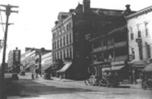](http://threadcity.com/articles/TomBeardsley/loomer/loomer1.htm)  
The grandest building on Main looks somewhat forlorn shortly before its demolition in 1940.

The Loomer Opera House was built by Silas Loomer, one of the prime movers in the growth of Willimantic in the years after the Civil War. Loomer was born at Hop River in Columbia, Connecticut in 1824. He was educated in the "old red school house" in Columbia, and at Ellington High School. He qualified to be a teacher, but the arrival of the railroads led to a change of career. He became involved in lumber and railroad supplies just as the Hartford, Providence and Fishkill railroad was being built in this part of the state. There was a demand for wood, ties, and lumber, and the enterprising Loomer made a fortune.

The railroads began his fortune. The arrival of the telegraph increased it. The telegraph companies needed poles to support their lines. Loomer provided them. In 1859 he represented Columbia in the General Assembly. In 1861 Loomer left Columbia for Willimantic and opened a coal, lumber, lime and cement business on North street in partnership with Hyde Kingsley. Loomer & Kingsley supplied the expanding railroad companies and textile industries. His fortune grew larger.

[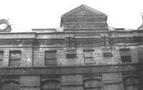](http://threadcity.com/articles/TomBeardsley/loomer/loomer2.htm)  
This excellent close up shot reveals some of the buildings fine architectural details.   [Continue...](http://threadcity.com/articles/TomBeardsley/loomer/index2.shtml)

**Silas Loomer (1824-1899):**

**Lumberman, Financier, Banker, Builder, Insurance Agent,   
Theater Builder, and Politician  
by: Tom Beardsley**

[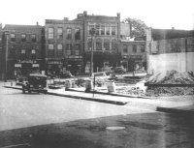](http://threadcity.com/articles/TomBeardsley/loomer/loomer5.htm)  
Its July, 1940, and only the first floor remains of the Loomer Opera House Block. The building next to it, the Shea Block, was demolished in 1951 and is now the site of Quinebaug Community Technical College.

Loomer became bored with lumber and coal. In 1878 he sold out and launched an insurance company, and ploughed much of his immense fortune into a fine new theater and commercial block. Loomer purchased a prime Main street site, fronting 72 feet, and extending back 240 feet on North street. The Loomer Opera House was long considered to be the finest theater in eastern Connecticut although the residents of Danielson claimed it was no match for their Music Hall. The Opera House was designed by F. H. Kimball, and seated 1,100 people. It was famous for its large stage, 60 foot wide and 40 foot deep. It had excellent acoustics, and was a favorite venue for touring companies members of which always lodged at the nearby Hooker House Hotel. In the early years of the 20th century, the management began showing silent movies, but the days of vaudeville were ending. The Loomer Opera House could no longer compete with custom built movie houses such as Willimantic's Gem and Capitol theaters.

[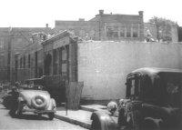](http://threadcity.com/articles/TomBeardsley/loomer/loomer4.htm)  
A view south down North Street showing the last stages of demolition.

The vast Opera House complex was expensive to heat and maintain, and in the late 1930s it was pulled down and replaced with a modern structure. The Loomer Opera House had dominated the Willimantic skyline for 61 years. It was one of the first buildings to be seen as rail passengers steamed into the city.

## [Continue...](http://threadcity.com/articles/TomBeardsley/loomer/index3.shtml) Silas Loomer (1824-1899):

**Lumberman, Financier, Banker, Builder, Insurance Agent,   
Theater Builder, and Politician  
by: Tom Beardsley**

[](http://threadcity.com/articles/TomBeardsley/loomer/loomer5.htm)  
This is the same view a few days later. The sixty-year old Theater is no more.

In 1885 Loomer returned to politics and became Windham's first selectman. He was also a director of Willimantic's Dime Savings and First National Banks, and a long-time president of the Willimantic Savings Institute. Loomer also was a director of the Air Line Railroad, on which Willimantic was often the only stop for the rapid rail service between Boston and New York City. Loomer's daughter Julia had married Willimantic's John Manning Hall, a president of the New York, New Haven & Hartford Railroad. Silas Loomer died on December 11, 1899, in the city he had helped to build and finance. He was 75. Along with men such as Lloyd Baldwin, Hugh Clark Murray, and Whiting Hayden, Loomer was an influential member of Willimantic's 19th century urban elite.

[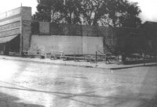](http://threadcity.com/articles/TomBeardsley/loomer/loomer6.htm)  
Several months later, the new Woolworth's, or "five and dime" store appears on this vacant site on Main Street. No more vaudeville shows for Willimantic!

The photographs were taken in the summer of 1940, when it was announced that the Loomer Opera House would be demolished. They provide a valuable historical documentation of life in Willimantic 70+ years ago.

[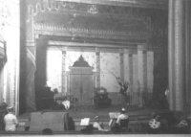](http://threadcity.com/articles/TomBeardsley/loomer/loomer7.htm)  
This photograph of a vaudeville performance in the Loomer Opera House was taken in the 1890s.   
  
  [The End.](http://threadcity.com/articles/index.shtml) 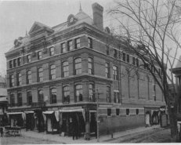The Loomer Opera House on Main Street, Willimantic was considered to be the finest theater between Hartford and Providence. It seated 1,200 people in lush surroundings. Many famous vaudeville acts played there, including Buffalo Bill Cody, Charlie Chaplin and Stan Laurel. Lumber magnate Silas Loomer built it in 1879. Movies were shown there in the 1920s, but it could not compete with the Capitol Cinema. The Opera House was demolished in 1940 and replaced by a new Woolworth's store.